Brainstorm

& idea prioritization

#### Use this template in your own brainstorming sessions so your team can unleash their imagination and start shaping concepts even if you're not sitting in the same room.

**1**

**Define your problem statement**

What problem are you trying to solve? Frame your problem as a How Might We statement. This will be the focus of your brainstorm.

**5 minutes**

**PROBLEM**

IoT-Based Safety Gadget for Child Safety Monitoring and Notification

[ IoT-Based Child safety monitoring system helps the parents in monitoring critical situation]

**2**

### Brainstorm

Write down any ideas that come to mind that address your problem statement.

**10 minutes**

**Kishore Kumar.T**

**SOS alert for connected mobile**

Trace whereabouts and Minimise the Tragedy

GPRS block is activated with SIM card on board

# Kenwin Patrick.A

## 

Real time Monitoring and safety support

Device that measures subterranean distance

**3**

### Group ideas

Take turns sharing your ideas while clustering similar or related notes as you go. Once all sticky notes have been grouped, give each cluster a sentence-like label. If a cluster is bigger than six sticky notes, try and see if you and break it up into smaller sub-groups.

**20 minutes**

Toddlers in hamlet and metropolis can be saved

#### Eradicates ambiguity and Pays way for a tech-driven community

ceaseless Survilliance and instantaneous notification regime

Durability and flexibility

**4**

**Prioritize**

Your team should all be on the same page about what's important moving forward. Place your ideas on this grid to determine which ideas are important and which are feasible.

**20 minutes**

### After you collaborate

You can export the mural as an image or pdf to share with members of your company who might find it helpful.

##### Quick add-ons

1. **Share the mural**

**Share a view link** to the mural with stakeholders to keep them in the loop about the outcomes of the session.

1. **Export the mural**

Export a copy of the mural as a PNG or PDF to attach to emails, include in slides, or save in your drive.

**10 minutes** to prepare

**1 hour** to collaborate

**2-8 people** recommended

##### Key rules of brainstorming

**Weightless**

To run an smooth and productive session

##### Keep moving forward

**Strategy blueprint**

Define the components of a new idea or strategy.

[**Open the template**](https://app.mural.co/template/e95f612a-f72a-4772-bc48-545aaa04e0c9/984865a6-0a96-4472-a48d-47639307b3ca)

**Customer experience journey map**

Stay in topic.

Toddlers in hamlet and metropolis can be saved

Detect the status of the child

Defer judgment.

Encourage wild ideas.

Listen to others.

Monitoring by

Understand customer needs, motivations, and obstacles for an experience.

[**Open the template**](https://app.mural.co/template/b7114010-3a67-4d63-a51d-6f2cedc9633f/c1b465ab-57af-4624-8faf-ebb312edc0eb)

**Build-In Battery**

Go for volume. If possible, be visual.

Eradicates ambiguity and Pays way for a tech-driven community

# Koushik Srinivasan Prasad.E

## 

Acquiring location coordinates

Short response time

High dependability and data accuracy

parents via GPS

**Two Way Communicat**

**Strengths, weaknesses, opportunities & threats**

Identify strengths, weaknesses, opportunities, and threats (SWOT) to develop a plan.

|  |  |
| --- | --- |
|  |  |
|  |  |

[**Open the template**](https://app.mural.co/template/6a062671-89ee-4b76-9409-2603d8b098be/ca270343-1d54-4952-9d8c-fbc303ffd0f2)

[**Share template feedback**](https://muralco.typeform.com/to/CiqaHVat?typeform-source=app.mural.co)

**ion**

Information is effortlessly accessible even if we are away from the actual location

It gives a sense of assurance and peace of mind to the parents

Create unassailable environment

instantaneous Message generation

Information is effortlessly accessible even if we are away from the actual location

Trace whereabouts and Minimise the Tragedy

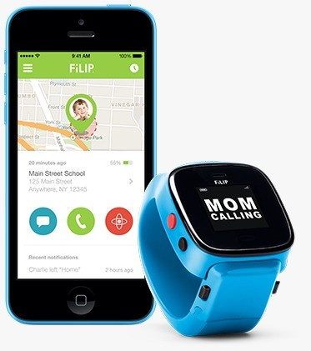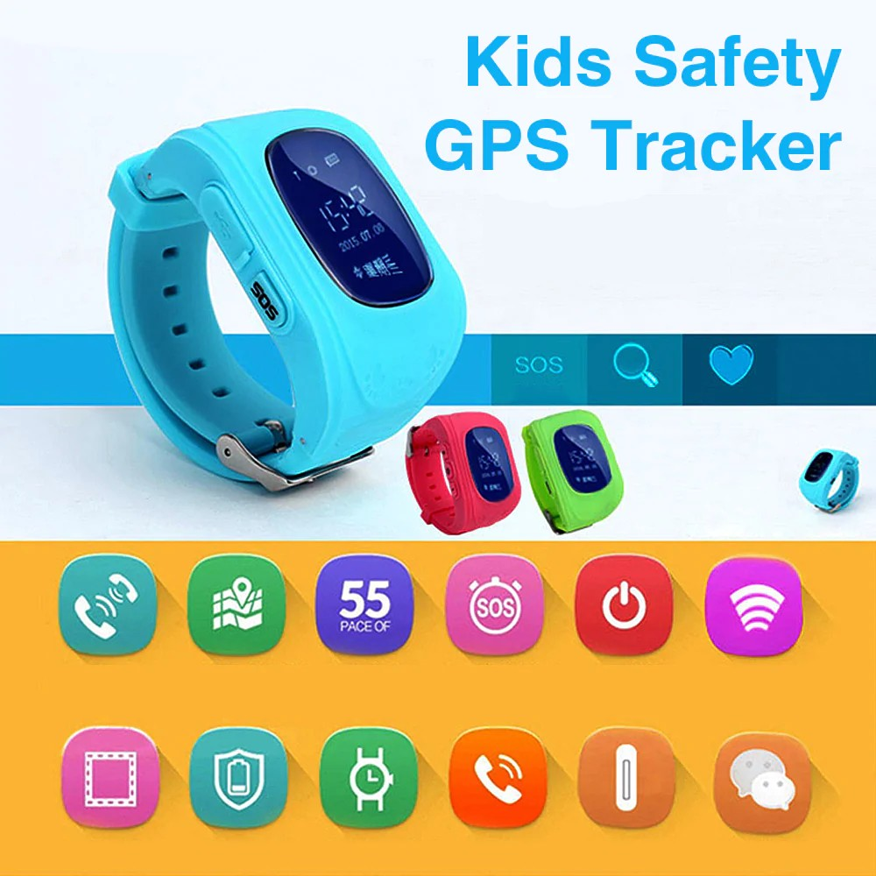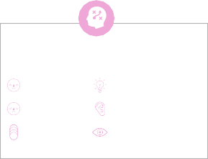

**Template**

[**Share template feedback**](https://muralco.typeform.com/to/CiqaHVat?typeform-source=app.mural.co)

**Real Time Alert**